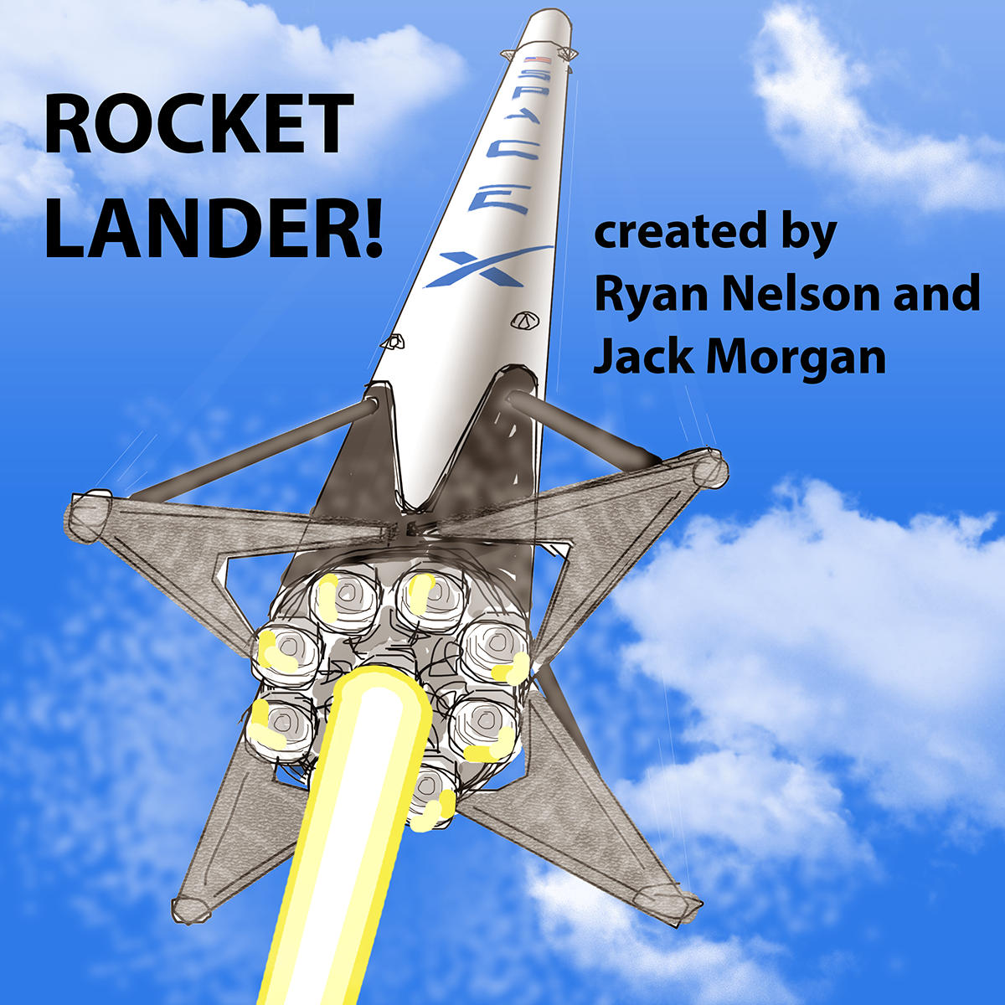

Midway Report

Revised: 9 April 2017

Summary of Progress:

* We’ve completed the sprite graphics and animations for the rocket main body, landing legs, thrusters, and engine flames.
* We’ve built the Rocket with all of its children and functions
* We’ve built the FuelBar IIFE
* We’ve built the smoke bitmap and connected it with rocket engine and thruster firing
* We’ve built the background images and a Background Manager for manipulating them
* We’ve built the Collider and its ability to track altitude of game objects
* We’ve tested all these built features inside the main game

**Project Backlog / Features (Updated)**

| Done? | Item Description | Category | Step | Responsible |
| --- | --- | --- | --- | --- |
| Yes | Build first version of the finished game | _CONCEPT | 0 | Ryan |
| Yes | Method to simulate solid surface at landing level (slice strategy) | _CONCEPT | 0 | Ryan |
| Yes | Specification Doc | _DESIGN | 1 | Ryan |
| Yes | Class diagram | _DESIGN | 2 | Ryan |
| Yes | High level Design diagram | _DESIGN | 2 | Ryan |
| Yes | Game Object diagram | _DESIGN | 2 | Jack |
| Yes | High Level Game Flow diagram (Events, Functions?) | _DESIGN | 2 | Jack |
| Yes | Revise game flow diagram | _DESIGN | 2 | Ryan |
| Yes | Revise game object diagram | _DESIGN | 2 | Ryan |
|  | Update object diagram | _DESIGN | 4 | Ryan |
|  | Update game flow diagram | _DESIGN | 4 | Ryan |
|  | Update specification document for final submission | _DESIGN | 5 | Ryan |
|  | Update object diagram for final submission | _DESIGN | 5 | Ryan |
|  | Update game flow diagram for final submission | _DESIGN | 5 | Ryan |
| Yes | Build spritesheet for rocket graphic | ANIMATION | 3 | Ryan |
| Yes | Build spritesheet for fire | ANIMATION | 3 | Ryan |
| Yes | Build spritesheet for thruster | ANIMATION | 3 | Ryan |
| Yes | Design animations for smoke wisp (fade and float upward), add location randomness to improve generation realism | ANIMATION | 3 | Ryan |
|  | Build spritesheet for explosion | ANIMATION | 5 | Jack |
| Yes | Develop collision detection object   * All functions, properties to do with collision * Trigger events if collision occurs | COLLIDER | 3 | Ryan |
| Yes | Track rocket position relative to landing site (altitude) | COLLIDER | 4 | Ryan |
| Yes | Build FuelBar IIFE   * Shapes / functions to visualize fuel levels | FUEL BAR | 4 | Ryan |
|  | **Build Game Manager IIFE to contain all properties, constants, variables, and functions related to gameplay**   * **Running game** * **Resetting game** * **Pausing game** * **Ending sequences** * **Move all current game functions into this object** | **GAME** | **4** | **Jack** |
|  | **Develop ability to change levels** | **GAME** | **4** | **Jack** |
|  | Develop Game Manager IIFE (additional methods and features) | GAME | 4 | Jack |
|  | Add point scoring system to rate how well player landed   * Proximity to landing circle (closer is better) * Amount of fuel remaining (more is better) * Angle of rocket (more vertical is better) * Velocity at landing (smaller is better) | GAME | 6?  Nice  To  Have | Jack |
| Yes | Zoom screen to 50% when open game in browser | GUI | 3 | Ryan |
|  | Build GUI IIFE (Hold Text objects, Fuel Remaining visualizations) | GUI | 4 | Jack |
|  | Build the paused text object | GUI | 4 | Jack |
|  | Build the physics statistics text object | GUI | 4 | Jack |
|  | Build update methods for GUI text on screen | GUI | 4 | Jack |
|  | Build generic method for text objects | GUI | 4 | Jack |
|  | Build the game hint text object | GUI | 4 | Jack |
|  | Build the explanation of gameplay shown at start and when game is paused (controls and objective), add to game | GUI | 4 | Jack |
| Yes | Draw rocket graphics (Body, Grid fins, Landing Legs, SpaceX Logo) | IMAGE | 2 | Ryan |
| Yes | Draw thruster graphics | IMAGE | 2 | Ryan |
| Yes | Draw fire graphics (Multiple sizes correspond with engine level) | IMAGE | 2 | Ryan |
| Yes | Draw the land-based background graphic | IMAGE | 2 | Ryan |
| Yes | Draw smoke graphic | IMAGE | 2 | Ryan |
| Yes | Draw loading screen graphic | IMAGE | 2 | Ryan |
| Yes | Draw the ocean-based background graphic | IMAGE | 2 | Ryan |
|  | Draw Explosion graphics | IMAGE | 5 | Jack |
|  | **Develop Input IIFE**   * **Put all constants, variables, properties, and functions related to input into one object** * **Move all current input functions into this object** | **INPUT** | **4** | **Jack** |
|  | **Develop Input Manager IIFE (additional methods and features)** | **INPUT** | **4** | **Jack** |
|  | **Add input to change game level** | **INPUT** | **4** | **Jack** |
|  | Create loading screen, add to game | LOADING | 5 | Jack |
| Yes | Build smoke bitmap method for locating, generating smoke | OBJECTS | 3 | Ryan |
| Yes | Build landing site object | OBJECTS | 3 | Ryan |
| Yes | Encapsulate smoke functions inside smoke object | OBJECTS | 4 | Ryan |
| Yes | Build land-based bitmap objects (background, slice) | OBJECTS | 4 | Ryan |
| Yes | Build ocean-based bitmap objects (background, slice) | OBJECTS | 4 | Ryan |
| Yes | Add vertical and horizontal velocity, momentum concepts | ROCKET | 3 | Ryan |
| Yes | Develop simulation of acceleration due to gravity | ROCKET | 3 | Ryan |
| Yes | Build Rocket Body Sprite | ROCKET | 3 | Ryan |
| Yes | Build Landing Legs Sprite | ROCKET | 3 | Ryan |
| Yes | Build Left and Right Thruster Sprites | ROCKET | 3 | Ryan |
| Yes | Build Fire Sprite | ROCKET | 3 | Ryan |
| Yes | Build points for smoke generation for engine fire levels | ROCKET | 3 | Ryan |
| Yes | Build points for smoke generation for thrusters | ROCKET | 3 | Ryan |
| Yes | Build Rocket container as an IIFE (objects, functions, properties, variables, constants associated with rocket) | ROCKET | 3 | Ryan |
| Yes | Build functions for rocket properties | ROCKET | 3 | Ryan |
| Yes | Build positioning and movement update methods | ROCKET | 3 | Ryan |
| Yes | Build listener addition function | ROCKET | 3 | Ryan |
| Yes | Build thruster and engine firing, cutout methods | ROCKET | 3 | Ryan |
| Yes | Build landing or crash methods | ROCKET | 3 | Ryan |
| Yes | Add animation methods for thrusters | ROCKET | 3 | Ryan |
| Yes | Add animation methods for main engine | ROCKET | 3 | Ryan |
| Yes | Change thrust animation based on thrust level | ROCKET | 3 | Ryan |
| Yes | Add thrust level concept | ROCKET | 3 | Ryan |
| Yes | Develop ability to change level of thrust | ROCKET | 3 | Ryan |
| Yes | Add concept of fuel levels, decreasing fuel when using equipment, no controls once fuel rules out | ROCKET | 3 | Ryan |
|  | Build sprite for explosion, add to rocket, add functions to rocket | ROCKET | 5 | Jack |